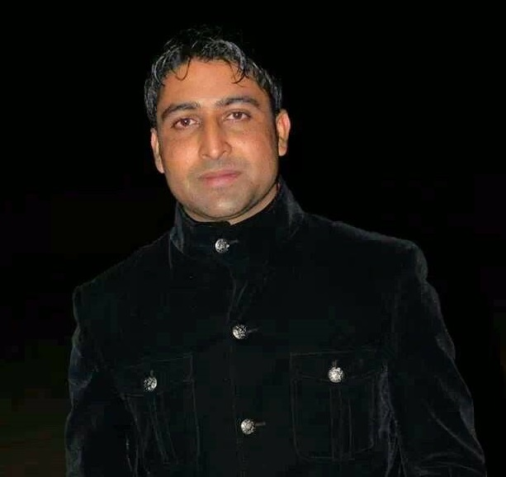
AMIR RIAZ KAYANI

S/O: Muhammad Riaz Kayani

Contact: 056-2682301
E-Mail: Amir.kiani66@gmail.com
AmirK@arabiannights.ae

Address: Arabian Nights for Travel & Tourism LLC. Abu Dhabi
SUBJECT: COMPUTER SCIENCE/ADMINISTRATION/ACCOUNTS/COMMUNICATION SYSTEM/INFORMATION TECHNOLOGY/NETWORKING

CAREER OBJECTIVES: -

Pursuing an experience where I will be able to utilize my life experience as well as my interpersonal skills, to not only allow myself to grow personally and professionally, but to firmly contribute towards the achievement of the mission and values of the company.

PERSONAL INFORMATION: -

Date of Birth : August 31, 1987
Religion : Islam
Marital status : Single
Nationality : Pakistani
Passport # : PV4119841
Emirates Driving License: Light Vehicle- #: 2161360 (Valid Until 2024)
Visa Status : Employment (Transferrable)

TECHNICAL QUALIFICATION: -

BS (Computer Science) Specialization: Telecommunication
CGPA : 3.51 / 4.00
Session : 2006 to 2010
From : Federal Urdu University of Arts, Science & Technology
Islamabad Pakistan
ACADEMIC QUALIFICATION: -

Intermediate (Pre-Engineering)
Percentage : 55 %
Session : 2004 to 2005
From : Board of Intermediate & Secondary Education, Mirpur AK

Matriculation (Science)
Percentage : 65 %
Session : 2002 to 2003
From : Board of Intermediate & Secondary Education, Mirpur AK

OTHER KNOWLEDGE: -

CCNA Discovery 4.0: Networking for home and Small Businesses
CCNA Discovery 4.0: Working at a small to Medium Business of ISP

Federal Urdu University of Arts, Science and Technology (F.U.U.A.S.T) Islamabad
Pakistan

TRAINING COURSES (Professional): -

- CCNA
- MCSE
- VOIP

FINAL YEAR PROJECT: -

Micro strip patch antenna’s designing using HFSS:
Antenna of 1.5 GHz : (Direct Antenna Modulation)
Antenna of 2.4 GHz : (Wi-Fi/WLAN Applications)
Antenna of 2.5 GHz : (Satellite & Army Communication System)
Antenna of 3.5 GHz : (Wi-Max Communication System)

MAJOR SUBJECT: -

Communication system, Digital Communication, Operating System, Wireless communication, Data & Computer Networks, Database & Management System, Network Management, Web Programming, Microwave Engineering

COMPUTER STRENGTH: -

- HFSS (Antenna Designing) | - Oracle 9i | - MS Word
- MS Power Point | - MS Excel | - Software Installation
- Web Browsing | - Windows Installation | - Internet & E-mail
- E-Travel | - Microsoft Dynamics ax AX
- PROTEL

INTERNSHIP: -

8 weeks at (ICT) PTCL Academy Islamabad Pakistan

- Understanding total infrastructure of CDMA system i.e. BTS, BSC, MSC, HLR, VLR,
- Understanding all subsystems of ZTE BTS
- Understanding all subsystems of ZTE BSC
- BSS configuration using OMC-R

LANGUAGES: -

English and Urdu

FIELDS OF INETERST: -

- Accounts
- Information Technology
- Antenna Designing
- Computer Networks
- Wireless Communication
- Code Division Multiple Access (CDMA)

EXPERIENCE: -

- Working as an Accountant General & IT related Work from Sep, 2012 at Arabian Nights for Travel & Tourism Abu Dhabi till the date

- Worked as an Computer system administrator for one year at TIP School & College RKT AJK

- Worked as a Customer sales representative for three months at Way Tech Outsourcing Solutions RWP Pakistan

REFERENCE: -

Will be provided on request

DECLARATION
I certify that all information stated in this resume is true and complete to the best of my knowledge.

